Lawn Spraying, Termite Protection
&. Indoor/Outdoor Pest Control

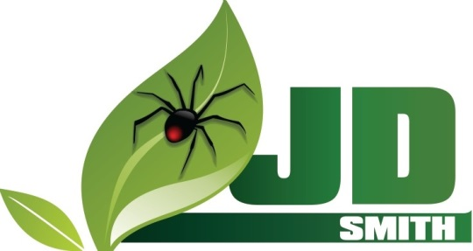
www.jdsmithpest.com

Pest Control
509 Lakeview Rd
Clearwater, FL 33756
jdsmithco@jdspest.com
(727) 443-0465 • (800) 860-5518

Attic Dusting
Release of Liability

This agreement releases JD Smith Company, Inc from all liability relating to damages that may occur during attic dusting. By signing this agreement, I agree to hold JD Smith Company, Inc entirely free from any liability, including financial responsibility for damages incurred.

I also acknowledge the risks involved in attic dusting. These risks include but are not limited to: dust leaking into the main living areas; a cloudy appearance in the home; dust settling on personal belongings. I swear that I am signing this release voluntarily, and that all risks have been made clear to me.

By signing below, I forfeit all right to bring a suit against JD Smith Company, Inc for any reason. I will make every effort to obey safety precautions as explained to me verbally. I will ask for clarification when needed.

I, __________________________, fully understand and agree to the above terms.

_________________________________ __________________
Signature Date

_______________________________ ___________________
Acct #
_______________________________
Address

